An Immersive Virtual World in Unity

# Claustrophobia Simulator

## Introduction

This assignment extends the learning materials and academic competencies taught on the SE3VR11 Virtual Reality course at the University of Reading [1]. It investigates the practicalities of using virtual reality to build applications that deliver an interactive virtual environment with a practical purpose.

In order to further absorb and reinforce the course content delivered on the SE3VR11 module two assignments are to be completed. The first was an Individual assignment to design and implement a virtual world in Unity [2]. This was satisfied with a virtual two storey house incorporating windows, interactive doors and light switches. Textures, materials and models are also used to increase the believability and immersion of the world.

## Background/Motivation

This assignment investigates the development of an immersive virtual reality application through completion of a group project. Each of the members is expected to contribute to the design and development of a virtual world that is utilitarian, immersive and realistic. The members are then to document their contribution towards the project by discussing the projects objectives, how their work contributed towards the project aims and how and if they were satisfied.

Currently VR has been used to create some innovative practical VR applications such as Virtual theatres for Doctors to practice critical surgeries or simulated environments to diagnose and treat phobias and illnesses [3]. With such a versatile use VR is being applied in the healthcare industry for treatments such as pain relief, fitness, rehabilitation etc. [4]

## Design/Requirements Analysis

The team discussed the possible applications that could be developed and there purposes. After researching current VR applications and simulations a conceptual design was reached. The team concluded on a claustrophobia simulator which would allow the user to experience, manage and train claustrophobia symptoms by introducing features and triggers into the world that trigger symptoms of the phobia [5]. The proposed environment would be comprised of four zones which would introduce features and scenarios that replicate real world common challenges a claustrophobic person may encounter in the world today such as elevators, revolving doors small cupboards etc. There would also be a comfortable starting area. The concept here is that each zone would become more of a challenge by introducing harder tasks to overcome and magnifying triggers in the environment. For example the last zone is located in the basement where there are no windows, very narrow hallways and small rooms compared to the Zone 1 which has wide hallways and fair size rooms. Aspects such as time constraints and team member numbers also dictated the design and concepts that could be proposed. This environment built up of zones essentially serves as the training or diagnostic suite for the application and then a separate environment would host a resizing/shrinking room that serves as a test suite. This is so that the user would be able measure there progression in some form from the training scene. Depending on the progression of the project other features such as a point scoring system for areas entered and features interacted with may be implemented. Figure 1 below shows the designed floor plan by the team.

**Figure.1 Original Floor plan design**

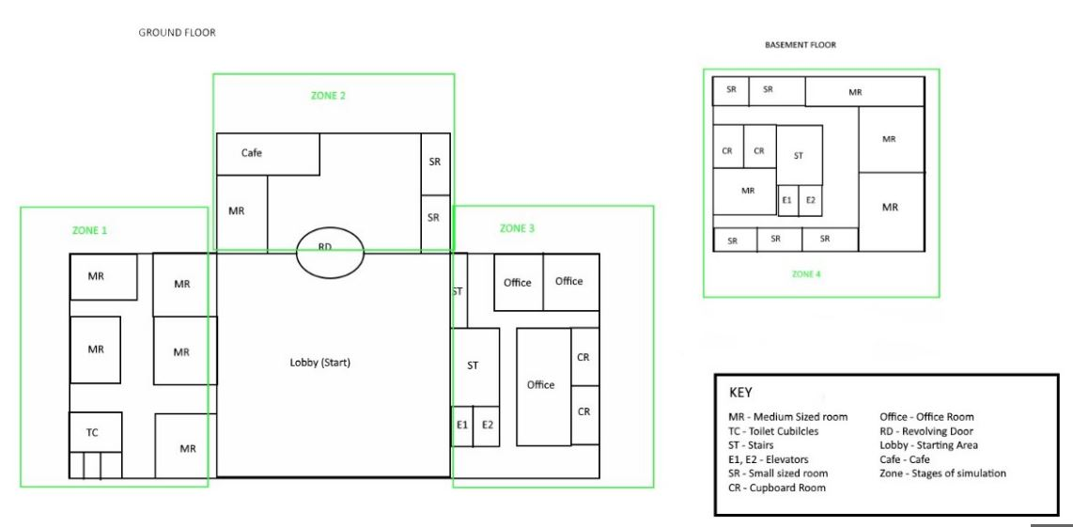

## Implementation

This report documents the development of Zone 3 of the simulator illustrated in the figure 1 floor plan. Zone 3’s main feature is the elevator, a common trigger for claustrophobia []. Considerations for the area being one of the last zones is taken into account where the size of the rooms are smaller, there is less lighting and more challenges incorporated in a smaller environment. There is one functional elevator and an alternative set of stairs if the user is not comfortable with the feature but still wishes to continue to the next area. Interactive openable/closable doors, 3d models and lighting are placed around the scene. Box colliders where implemented for the models to represent physical mass and enhance the realism of the virtual world. The lift has an empty collider which is triggered when the user enters to pare the FPS Controller object with the elevator object. There are two small cupboard rooms a closet toilet and two slighter larger offices. The biggest room has two entrances with no doors which has a conference table and office chairs with physical attributes Figure 2 below displays a screenshot of Zone 3.

**Figure.2 Screen Shot of Zone 3**

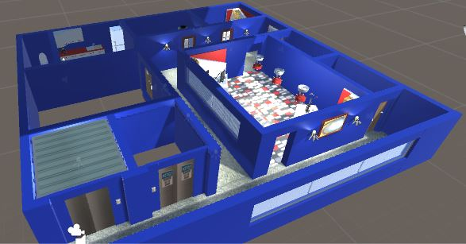

## Testing and Results

The main methods of testing where carried out by myself and other team members. Some testing was carried out by course associates. In the ideal practice of testing users with diagnosed claustrophobia would provide the best quality of test results. Unfortunately expanding the testing scope that far is unrealistic for timescale designated for the project.

Object Collision Test

3D models and walls where tested for the resilience by walking into them. The box colliders implemented represented realistic physical mass for the objects in the rooms such as the office desks, wall paintings and lamps. The kitchen units, fridge and toilet all functioned correctly in regards to physical presence.

Feature Interaction Test

**Elevator**

The exterior elevator button after pressed summons the elevator up to the first floor and opens the interior and exterior doors. The door animations here are offset and not correctly timed so that the lift can be seen by the user coming up the shaft. After entering the lift and clicking the interior button there a slight glitch with FPS Controller whilst the animation is playing. This also happens on the way back up but essentially the lift does deliver a sense of enclosure to user. When arriving at the basement and clicking the interior lift button in order to the open doors and exit the lift proceeds to play the up motion animation which makes user either run for exit quickly or ride the lift back to the top. The exterior and interior elevator buttons where pressed rapidly throughout the animation being played which caused the doors and elevator operations to fall out of synch. If the user rapidly clicks on the elevator button whilst the animations are playing they fall out of synch. This can be fixed with some error handling that will prevent the user clicking more than once until animation has finished playing or queueing the animations.

**Doors**

Each of the doors where tested by clicking anywhere on the doors. All doors in the zone functioned correctly playing audio clips for the open and close door sound effects.

**Lighting and Rendering**

After a few initial runs of the scene some lighting was removed as areas where too intense and did not match the desired effect for the rooms. Walls, ceiling and connecting structures where refined to give a better finish.

## Results and Discussion

The sense of enclosure and restriction was projected by the small cupboard and toilet rooms. Rooms that featured closable doors enhanced that feeling and reality. The textures and shadings contributed to the realism. The offices and kitchen also contributed to the desired effects of the simulation.

Although the elevator could provide a means of access to zone 4 its realism was unfortunately spoilt by glitching and uncoordinated animations. Clearly some extra functionality needs to be implemented on the elevator to manage the door operations when entering and exiting the lift. As the user clicks the button to open the doors on arrival of the basement floor the elevator proceeds to go back up. There also a problem of when the user takes the stairs and then then the elevator.

Some 3D models had to be removed as the application became very resource intensive with the array of 3D models the world featured. Less detailed models could be used to reduce the size of the application. The doors and office chairs function correctly.

## Conclusion

The finished simulation provided an interactive environment with features and challenges targeted towards claustrophobia. The use of animations and 3D models in the scene that the user could relate to added to the realism. The training scene simulator objects but unfortunately time being a huge factor on this project the development of the resizing room was not complete. This simulator would be more recognisably purposeful with the fulfilment of the original design.

Believability of some of the features such as the elevator did not meet expectations. Although the lift itself still provided that visual representation of being in a lift the operations did not however. Through completing this task I how broadened my skills of game animations, mechanism to create a virtual environment and what types of interactive features add to an immersive world.

## Further Work

Light switches could be implemented in the cupboard rooms. Correcting and perfecting the elevator operations would be a high priority being it a main feature of the application.

If a heart rate receiver from something as common as a smart phone could input readings from a user into the environment then even more interactive control and immersive reality can be achieved.

## References

[1] SE3VR11, UOR Blackboard. Available at: <https://www.bb.reading.ac.uk/webapps/blackboard/execute/announcement?method=search&context=course_entry&course_id=_113341_1&handle=announcements_entry&mode=view>

[2] A simple Virtual World by Tom Bedford

[3] Claustrophobia, Causes, symptoms and treatments, MNT. Available at: <http://www.medicalnewstoday.com/articles/37062.php>

[4] Advances of virtual reality in medical technology. Available at: <http://rx4group.com/advances-of-virtual-reality-in-medical-technology-business/>

[5] Common trigger for claustrophobia, Phobias.com. Available at: <http://phobias.about.com/od/phobiasatoh/f/What-Is-The-Fear-Of-Elevators.htm>